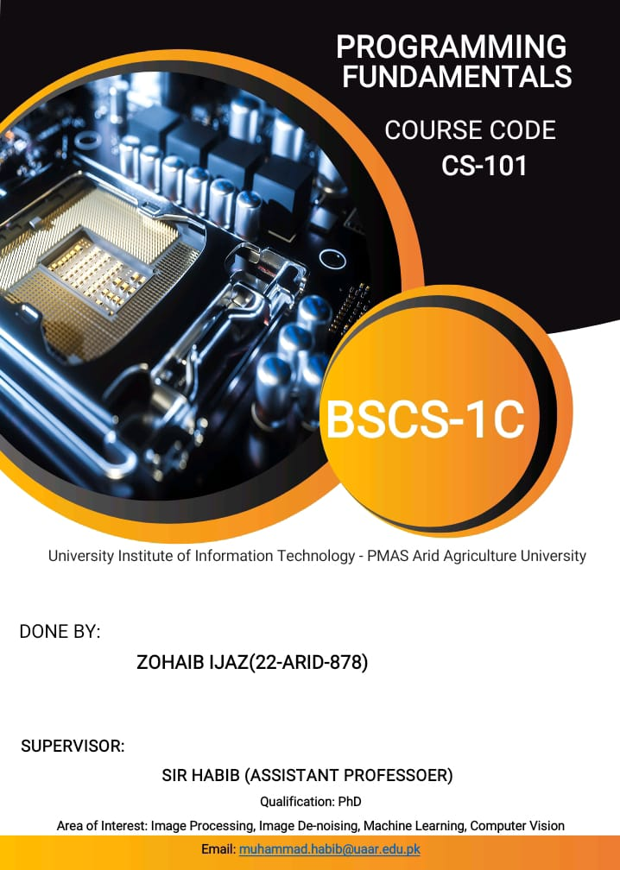

**ABSTRACT:**

C++ provides rich library support in the form of Standard Template Library (STL). C++ program on CASINO GAME is simple text base number guessing game. This project spatiality is we use in procedure oriented approach C++ is a high-level object-oriented programming language that helps programmers write fast, portable programs. to design casino number guessing game. With this guessing game player can deposit his money to play. From this amount he can bet on number between 1 and 10. If he wins he gets 10 times of money otherwise lost his money. As casino is played worldwide and is quiet a risky game, this number guessing game will help us in making better economic decisions .This project is very interesting project when users play this, they will really like the project.

**ALGORITHM :**

**1**.Start

**2**.Read variables Player name,Amount

**3**.do

Read Betting amount

while(choice==y||choice==n)

**4**.if (Betting amount>Amount)

(read guess ) (dice=rand()%10 + 1)

else

Display re-enter the Betting amount

**5**.if guess=Dice amount

Amount=Betting amount*10

else

Amount=Amount-Betting amount

**6**.Repeat steps 3,4,5

**7**.Stop

**RESULT AND DISCUSSION:**

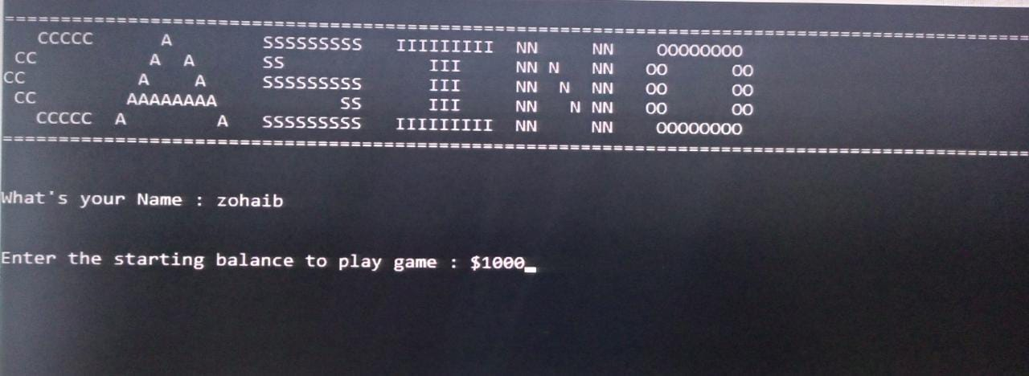

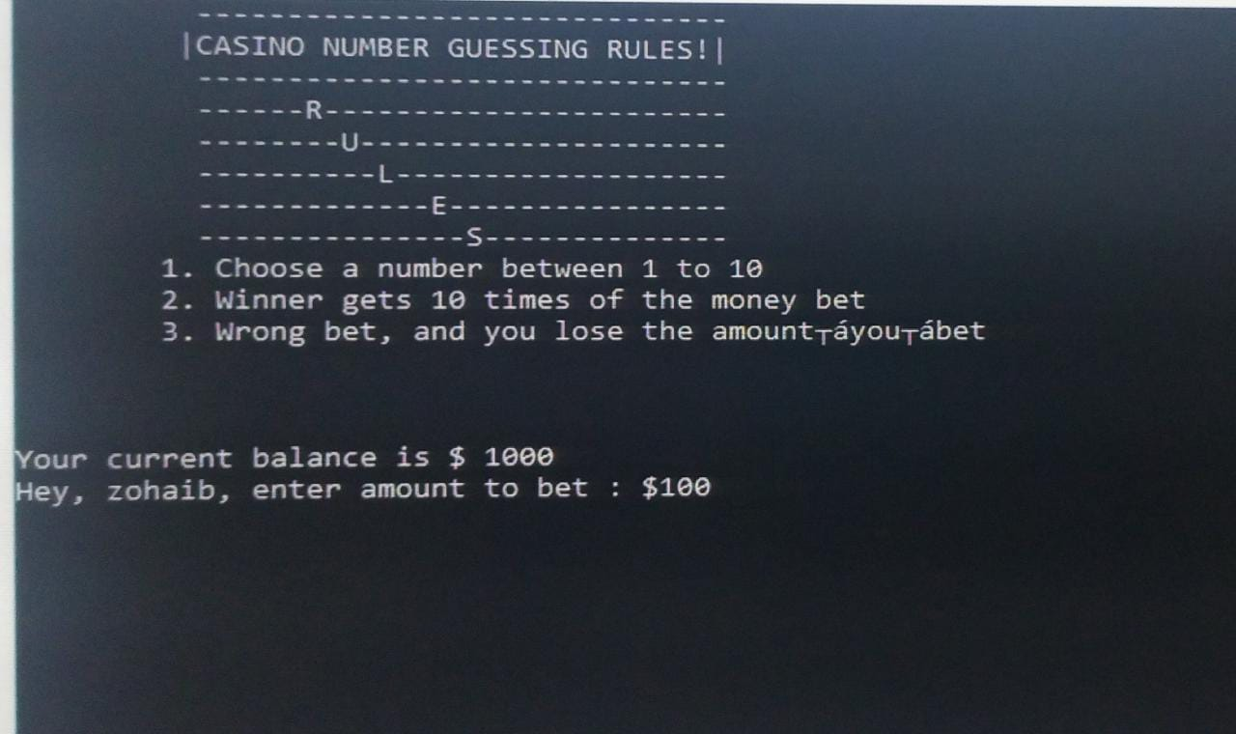

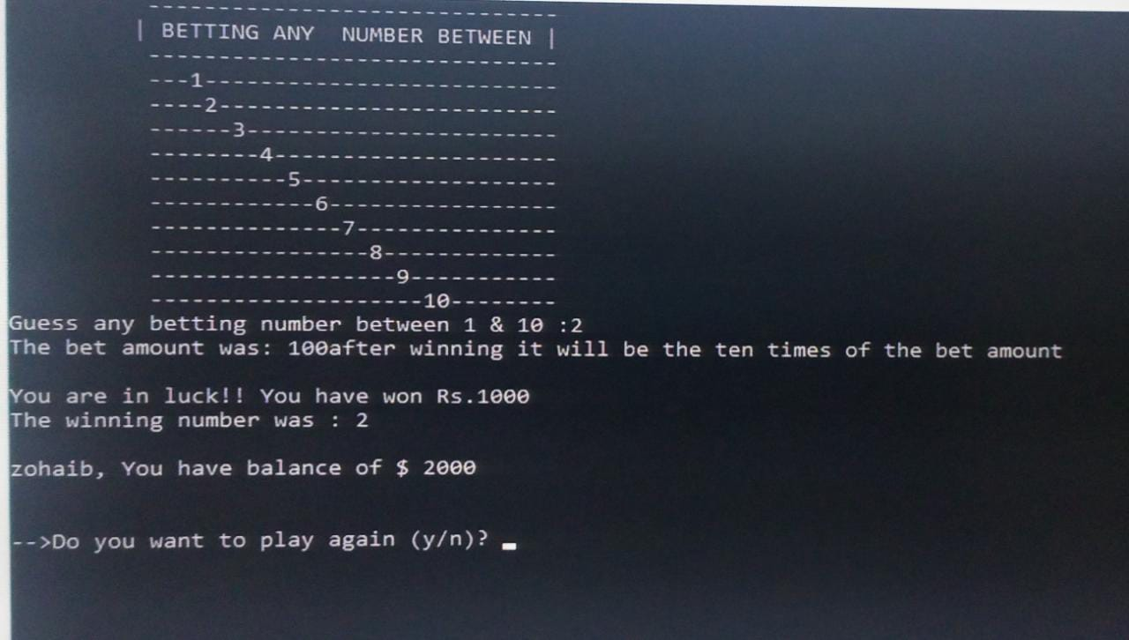

After running the program, we have to enter our name along with the amount to be deposited. After that we will be taken to another screen where the rules of the game are displayed .Below the rules, the amount left with us will be displayed i.e., current balance. After knowing our current balance we have to bet the amount on a number i.e. betting amount. If we win, our current balance becomes ten times the betting amount else, our current balance will be decreased by the betting amount. Later we got an option to decide whether we want to play the game again or no.

**Step 1: (header files)**

#include <iostream>

#include<fstream>

#include <string>

#include <cstdlib>

#include<time.h>

#include<windows.h>

**Step 2 : (structures )**

struct User{

string playerName;

int balance;

int bettingAmount

};

struct User2{

int guess;

int dice;

};

**Step 3 : (functions)**

void rule_1();

void rule_2();

void rule_3();

void rule_4();

void rule_5();

**step 4: (file handling)**

fstream myFile;

string line;

myFile.open("user_data.txt",ios::out);

if(myFile.is_open()){

cout<<"Enter you name"<<endl;

getline(cin, obj.playerName);

myFile<<"USER NAME :"<<obj.playerName<<endl;

cout<<"Enter your starting balance to play game :$";

cin>>obj.balance;

myFile<<endl<<"TOTAL BALANCE :"<<obj.balance;

myFile.close();

}

else

cout<<"Your file is not open"<<endl;

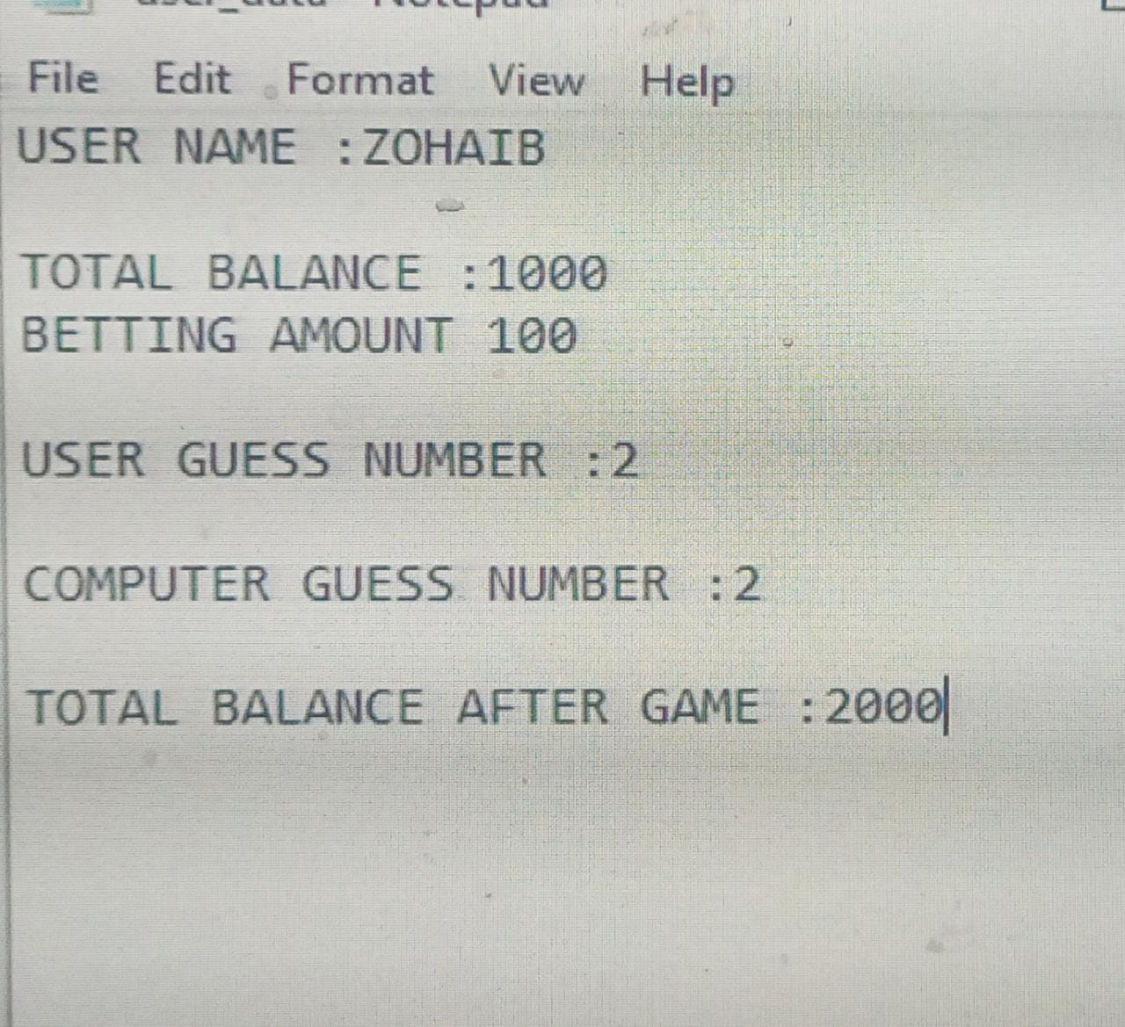

**CONCLUSION :**

In this casino guessing game the player can see the amount he has played on, the right decision to be made, by showing the amount he will win or lose by playing a number. The player can add all the details including the number played and amount left. The player can finally play his chance by following the instructions given by the

software. Since casino games are being played enormously worldwide, this source code is developed to avoid taking risky decisions. In this game you either become a billionaire or go bankrupt. No need to worry about the pre knowledge and experience, the computer will take care of your decision making.

**Code :**

#include <iostream>

#include<fstream>

#include <string>

#include <cstdlib>

#include<time.h>

#include<windows.h>

using namespace std;

void rule_1();

void rule_2();

void rule_3();

void rule_4();

void rule_5();

struct User{

string playerName;

int balance;

int bettingAmount;

};

struct User2{

int guess;

int dice;

};

int main()

{

User obj;

User2 obj2;

char choice;

cout<<"\n===============================================================================================";

cout<<"\n CCCCC A SSSSSSSSS IIIIIIIII NN NN OOOOOOOO ";

cout<<"\n CC A A SS III NN N NN OO OO ";

cout<<"\nCC A A SSSSSSSSS III NN N NN OO OO ";

cout<<"\n CC AAAAAAAA SS III NN N NN OO OO ";

cout<<"\n CCCCC A A SSSSSSSSS IIIIIIIII NN NN OOOOOOOO ";

cout<<"\n===============================================================================================\n";

int no=0;

fstream myFile;

string line;

myFile.open("user_data.txt",ios::out);

if(myFile.is_open()){

cout<<"Enter you name"<<endl;

getline(cin, obj.playerName);

myFile<<"USER NAME :"<<obj.playerName<<endl;

cout<<"Enter your starting balance to play game :$";

cin>>obj.balance;

myFile<<endl<<"TOTAL BALANCE :"<<obj.balance;

myFile.close();

}

else

cout<<"Your file is not open"<<endl;

do

{

system ("cls");

rule_1();

rule_2();

rule_3();

rule_4();

rule_5();

cout << "\n\nYour current balance is $ " << obj.balance << "\n";

do

{

cout << "Hey, " << obj.playerName<<", enter amount to bet : $";

cin >> obj.bettingAmount;

myFile.open("user_data.txt",ios::app);

myFile<<endl<<"BETTING AMOUNT "<<obj.bettingAmount<<endl;

myFile.close();

if(obj.bettingAmount > obj.balance)

cout << "Betting balance can't be more than current balance!\n"

<<"\nRe-enter balance\n ";

}while(obj.bettingAmount >obj.balance);

do

{

system("cls");

char x=177;

cout<<"\n\n\n\n\n\n\tHIT THE JACKPOT $$$$$$$$$";

for(int i=1;i<=30;i++){

cout<<x;

Sleep(150);

}

system("cls");

cout<<" ------------------------------\n";

cout<< " | BETTING ANY NUMBER BETWEEN |\n";

cout<<" ------------------------------\n";

cout<<" ---1--------------------------\n";

cout<<" ----2-------------------------\n";

cout<<" ------3-----------------------\n";

cout<<" --------4---------------------\n";

cout<<" ----------5-------------------\n";

cout<<" ------------6-----------------\n";

cout<<" --------------7---------------\n";

cout<<" ----------------8-------------\n";

cout<<" ------------------9-----------\n";

cout<<" --------------------10--------\n";

cout << "Guess any betting number between 1 & 10 :";

cin >>obj2.guess ;

myFile.open("user_data.txt",ios::app);

myFile<<endl<<"USER GUESS NUMBER :"<<obj2.guess<<endl;

myFile.close();

if(obj2.guess <= 0 || obj2.guess > 10)

cout << "\nNumber should be between 1 to 10\n"

<<"Re-enter number:\n ";

}

while(obj2.guess <= 0 ||obj2.guess > 10);

obj2.dice = rand()%10 + 1;

myFile.open("user_data.txt",ios::app);

myFile<<endl<<"COMPUTER GUESS NUMBER :"<<obj2.dice<<endl;

myFile.close();

if(obj2.dice == obj2.guess)

{

cout<<"The bet amount was: "<<obj.bettingAmount << " after winning it will be the ten times of the bet amount";

cout << "\n\nYou are in luck!! You have won Rs." << obj.bettingAmount * 10;

obj.balance = obj.balance + obj.bettingAmount * 10;

myFile.open("user_data.txt",ios::app);

myFile<<endl<<"TOTAL BALANCE AFTER GAME :"<<obj.balance<<endl;

myFile.close();

}

else

{

cout << "Oops, better luck next time !! You lost $ "<< obj.bettingAmount <<"\n";

obj.balance = obj.balance - obj.bettingAmount;

myFile.open("user_data.txt",ios::app);

myFile<<endl<<"TOTAL BALANCE AFTER GAME :"<<obj.balance<<endl;

myFile.close();

}

cout << "\nThe winning number was : " << obj2.dice <<"\n";

cout << "\n"<<obj.playerName<<", You have balance of $" << obj.balance << "\n";

if(obj.balance == 0)

{

cout << "You have no money to play ";

break;

}

cout << "\n\n-->Do you want to play again (y/n)? ";

cin >> choice;

}

while(choice =='Y'|| choice=='y');

cout << "\n\n\n";

cout << "\n\nThanks for playing the game. Your balance is $ " << obj.balance << "\n\n";

return 0;

}

void rule_1()

{

system("cls");

char x=177;

system("cls");

cout<<"\n\n\n\n\n\n\n\tTHAT'S THE TRUTH ABOUT PAKISTAN...WE'RE THE ONLY WINNERS. THE PLAYERS DON'T STAND A CHANCE.";

for(int i=1;i<=30;i++)

{

cout<<x;

Sleep(250);

}

}

void rule_2()

{

system("cls");

cout<<" ------------------------------\n";

cout<< " |CASINO NUMBER GUESSING RULES!|\n";

cout<<" ------------------------------\n";

cout<<" ------R-----------------------\n";

cout<<" --------U---------------------\n";

cout<<" ----------L-------------------\n";

cout<<" -------------E----------------\n";

cout<<" ---------------S--------------\n";

}

void rule_3()

{

cout << "\t1. Choose a number between 1 to 10\n";

}

void rule_4()

{

cout << "\t2. Winner gets 10 times of the money bet\n";

}

void rule_5()

{

cout << "\t3. Wrong bet, and you lose the amount you bet\n\n";

}